**Name:- Sharaf Nagatheja**

**Email:-** [**nasharaf@iu.edu**](mailto:nasharaf@iu.edu)

**Id:- 2000927206**

**Computer Networks Assignment 1**

**Task1:**

1. Send a message while connected to the IU mail server with the following info:
   * To: sice-networks-l@list.indiana.edu
   * From: <YOUR IU EMAIL>
   * Subject: “<YOUR NAME> Assignment 01 SMTP”

1. Capture the successful SMTP exchange in your terminal session and submit as a text document.

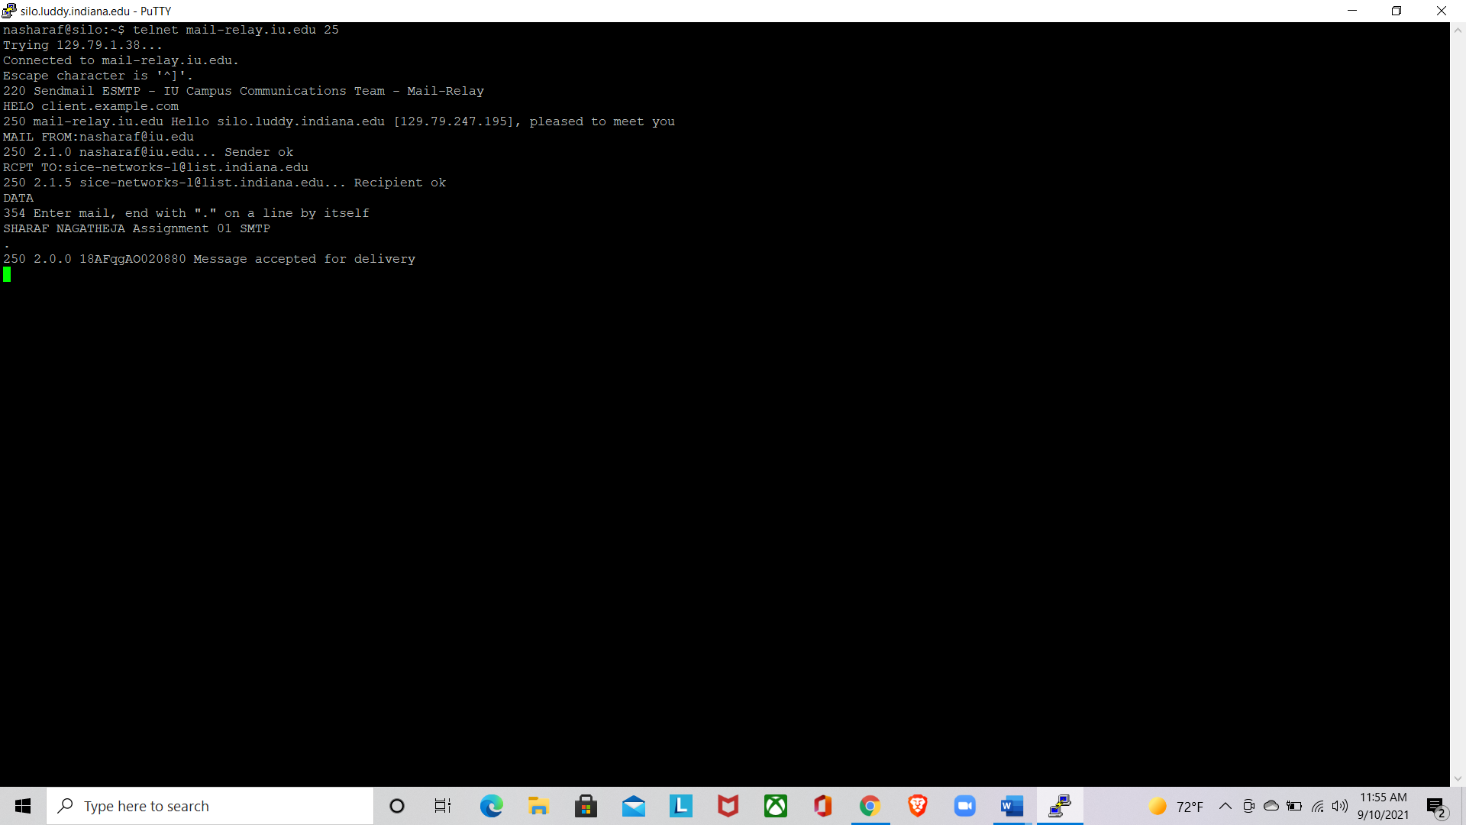

1. Answer the following questions and submit with part (2) above.
   * What happens when you try to send to a non-IU email address? Why?
   * What happens when you use a made-up from address? Why?

->When we try to send to a non-IU email address it will get us relaying denied and a proper authentication required message because in server side scripting non iu emails are been restricted.

->Yeah it works fine even if we keep a made up iu email address then the recipient can get that email but non Iu email will get authentication error because it is inside the network and does not have smtp authentication protocol which leads to email spoofing

**Task 2**

**Write a simple SMTP client**

**Python code:**

import socket

class UsageError(Exception): pass

class Netcat(object):

def connect(self, host, port):

if not isinstance(host, str):

raise UsageError("Host must be ip address or resolvable url")

try:

addr = socket.getaddrinfo(host, port, proto=socket.IPPROTO_TCP)[0][4]

except IndexError:

raise UsageError("Unknown hostname or IP")

self.socket = socket.socket(socket.AF_INET, socket.SOCK_STREAM)

self.socket.connect(addr)

def read(self, length=1024):

return self.socket.recv(length)

def write(self, data):

self.socket.send(data.encode('utf-8'))

def close(self):

self.socket.close()

sender_email = input("enter email id: ")

reciever_email = input("enter receiver email: ")

subject = input("enter subject of email: ")

f = open("file.txt","w+")

for i in range(10):

f.write("This is line %d\r\n" % (i+1))

f.close()

f=open("file.txt", "r")

body_data = f.read()

f.close()

nc = Netcat()

nc.connect('mail-relay.iu.edu',25)

print(nc.read(1024).decode("utf-8"))

nc.write("helo silo.sice.indiana.edu\r\n")

print(nc.read(1024).decode("utf-8"))

nc.write("MAIL FROM:{}\r\n".format(sender_email))

print(nc.read(1024).decode("utf-8"))

nc.write("RCPT TO:{}\r\n".format(reciever_email))

print(nc.read(1024).decode("utf-8"))

nc.write("DATA\r\n")

nc.write("SUBJECT:{}\r\n".format(subject))

print(nc.read(1024).decode("utf-8"))

nc.write("\r\n {}".format(body_data))

nc.write("\r\n.\r\n")

print(nc.read(1024).decode("utf-8"))

